Name :- Arghya Patra

Roll No. :- 23052067

Branch :- Computer Science

Section :- 39

Subject :- DBMS Lab

Semester :- 4th

2.

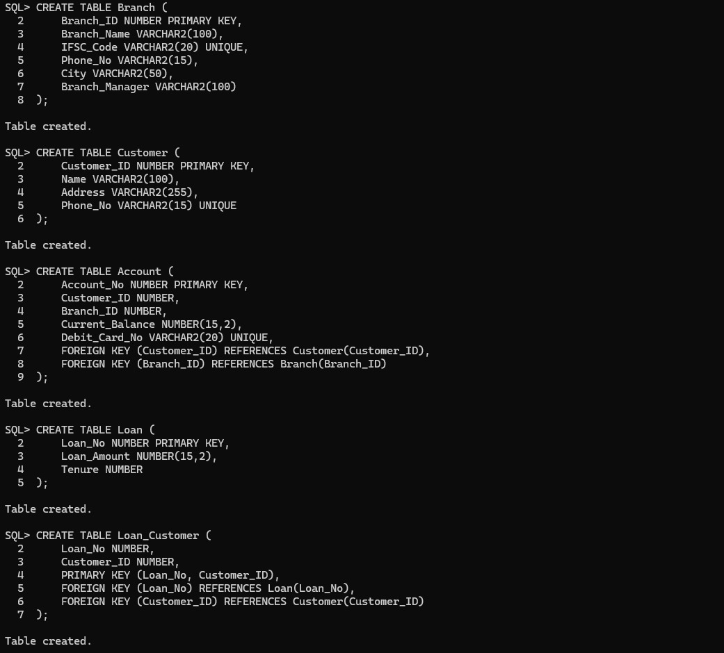

3.

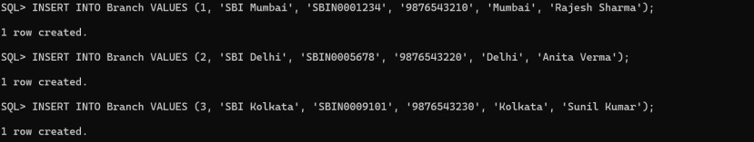

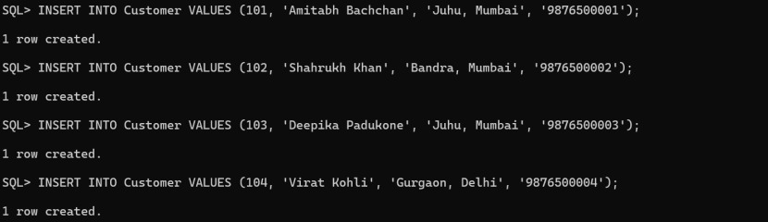

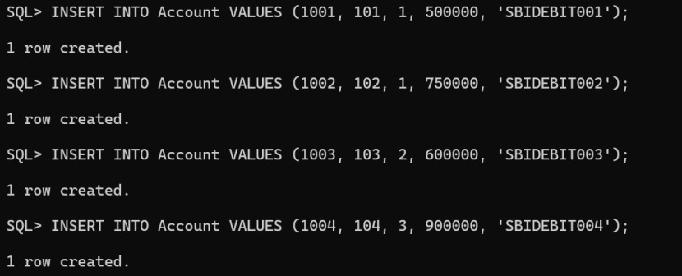

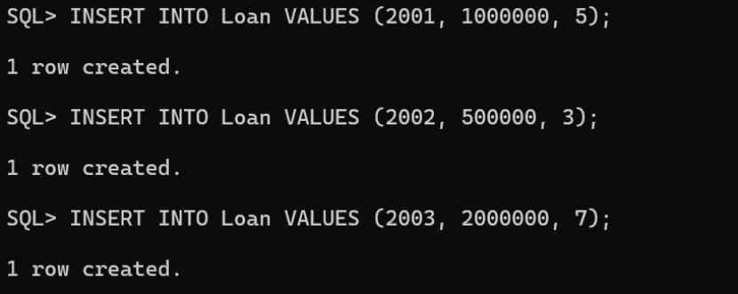

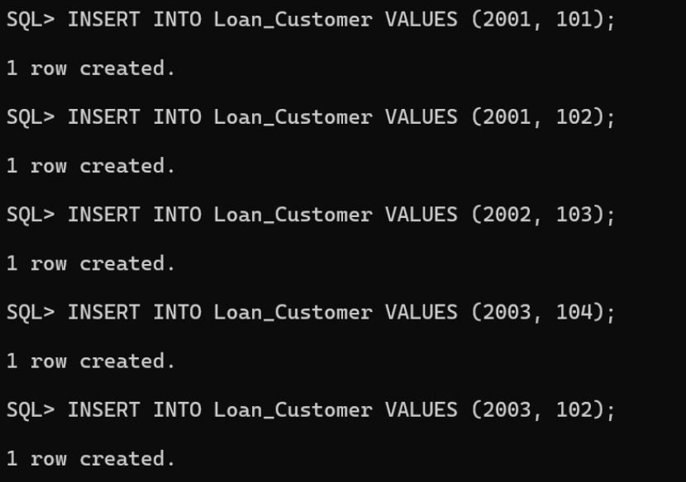

4.i)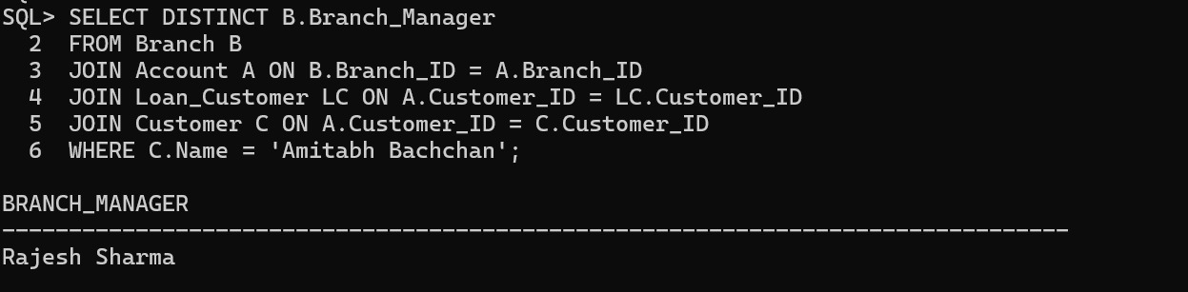

ii)

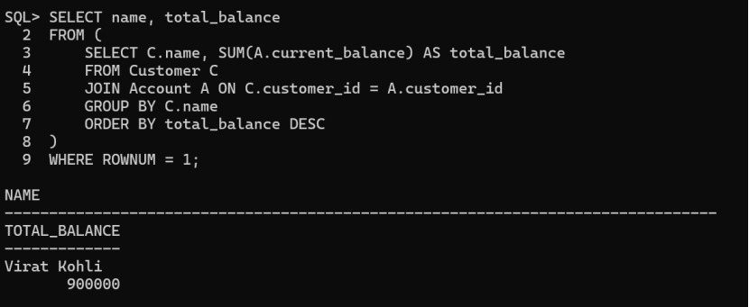

iii)

